FARM STORE – IMAGES

Fertilizers

1. ***Eagle Micronutrient***

Price :- 95/kg

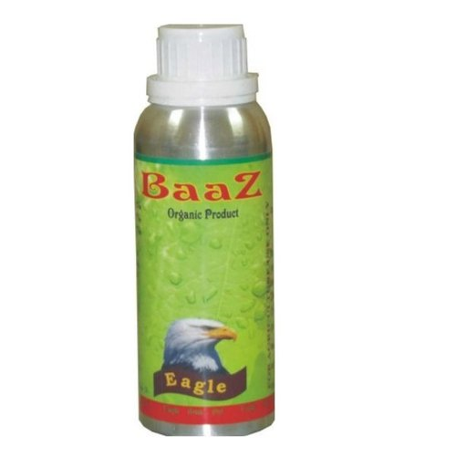

### Product Specification

|  |  |
| --- | --- |
| Grade | Agriculture Grade |
| Packaging Size | 100 ml |
| Packaging Type | HDPE Bottles |
| Form | Liquid |
| Brand | Eagle |
| Purity | 99% |

**Product Description**

The 13 mineral nutrients, which come from the soil, are dissolved in water and absorbed through a plant's roots. There are not always enough of these nutrients in the soil for a plant to grow healthy. This is why many farmers and gardeners use fertilizers to add the nutrients to the soil. Eagle Micronutrients are those elements essential for plant growth which are needed in only very small (micro) quantities. These elements are sometimes called minor elements or trace elements, but the use of the term micronutrient is encouraged by the American Society of Agronomy and the Soil Science Society of America. The micronutrients are **Boron (B), Copper (Cu), Iron (Fe), Chloride (Cl), Manganese (Mn), Molybdenum (Mo)**and **Zinc (Zn)**. Recycling organic matter such as grass clippings and tree leaves is an excellent way of providing micronutrients (as well as macronutrients) to growing plants.

1. **Organic Bio Fertilizers, Pack Type: Pp Bag**

**Price:-** 30\kg



### Product Specification

|  |  |
| --- | --- |
| Pack Type | PP Bag |
| Brand | SBT |
| Usage/Application | Agriculture |
| Packaging Size | 25 and 50 Kg |
| Purity | 99 % |
| Is It Organic | Organic |

### Product Description

Backed by advanced infrastructure, we are indulged in offering a wide array of **Organic Bio Fertilizers,**which demand due to their precise formulation. These products have longer shelf life and safe to use. Besides this, customers can avail these products from us in bulk quantity at inexpensive prices.

1. **KMB Potash Mobilizing Bacteria, Packaging Type: Hdpe Bottle And Drum**

Price:- 10000\order

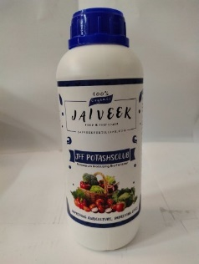

### Product Specification

|  |  |
| --- | --- |
| Packaging Type | HDPE Bottle and Drum |
| Color | Brown |
| Types Of Biofertilizers | KMB |
| Usage/Application | Fruits like Banana, Water Melon, Pappaya, Grapes, Pomegranate, All vegetables & flowers, Wheat |
| Form | Liquid |
| Packaging Size | 1 LTR HDPE Bottle to 200 LTR Drum |
| Purity | 5x10^8 Bacterial Count |
| Potash | CFU - 5x10^8 |
| Country of Origin | Made in India |
| Minimum Order Quantity | 200 Order |

### Product Description

**Potassium Mobilizing Bioferilizer**

Potash Mobilizer is a beneficial bacterium capable of mobilizing  Potassium Potassium available in soil into the root zone of plants. It works well in all types of soil. When applied to soil, potash mobilising bacterium multiplies, and helps to mobilise potassium fixed in soil. This mobilized potassium is easliy available to the plants. The mobilizing power is so high that it can save upto 50-60% of the chemical fertilizer.

**Product Details:**

·         Minimum Order Quantity : 100 Litre

·         Brand : JFF POTASHSOLUB

·         Pack Size : 500 ML, 1 Litre, 50 Litre, 200 Litre

·         Pack Type : Bottles, Drums

·         Usage : Agriculture, Fertilizer

·         State : Liquid

1. Biofertilizer PGPR P Sol B-PS (Pseudomonas Striata), For Soil,Foliar Application, Packaging Type: Aluminium Pouches

**Price** :- 70\kg

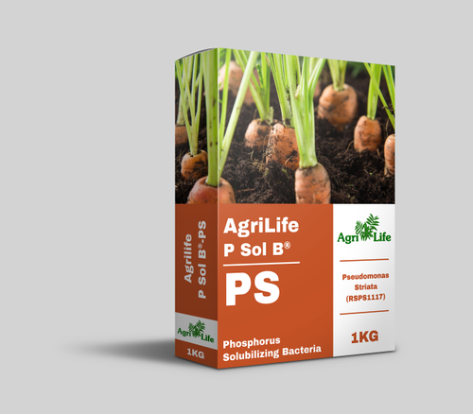

### Product Specification

|  |  |
| --- | --- |
| Packaging Type | Aluminium Pouches |
| Types Of Biofertilizers | Pgpr |
| Packaging Size | 100g,250g,500g,1kg |
| Product Type | BioFertilizer |
| Usage/Application | Soil,Foliar Application |
| Grade Standard | Bio-Tech Grade |

### Product Description

**Introducing P Sol B®-PS**  
  
P Sol B® – PS is a biological fertilizer based on a selected strain of naturally-occurring beneficial bacteria  Pseudomonas striata  (NCIM 2847). It is used as an effective soil inoculant.  
  
P Sol B®– PS contains vegetative cells of Pseudomonas striata. It is formulated as Wettable Powder with CFU count of 5 X 10 ^ 7 / g. P Sol B TM– PS is registered under the Fertilizer Control Order- Govt of India. P Sol B® – PS is approved for use in Organic Agriculture.   
  
Phosphorus is abundant in several soils and is one of  the major nutrients limiting the plant growth. The overall Phosphorus use efficiency following phosphate fertilizer application is low because of the formation of insoluble complexes Therefore this mandates frequent application of soluble forms of inorganic Phosphorus necessary for crop production. This results in leaching to the ground water and results in eutrophication of aquatic systems and pollutes soil.

1. Bio Vita-Z

Price:- 599\bottle

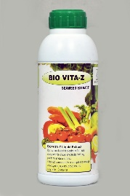 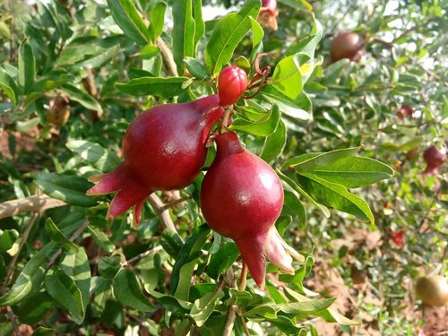 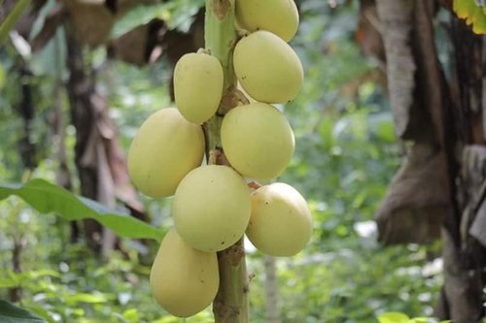 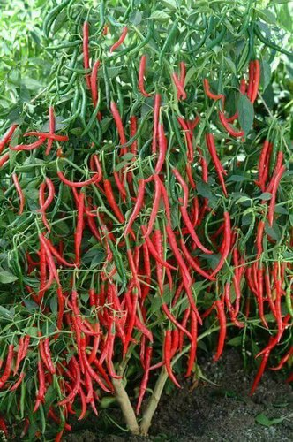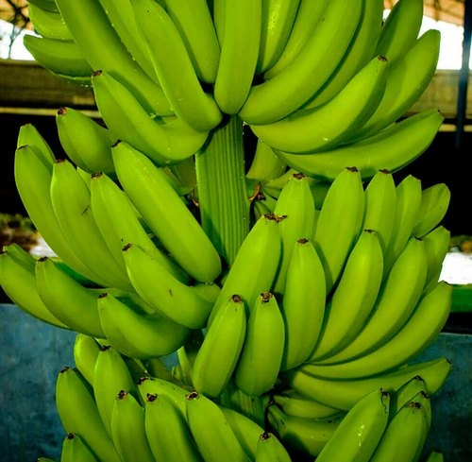

### Product Specification

|  |  |
| --- | --- |
| Brand | zeal Biologicals |
| Usage/Application | spray |
| Minimum Order Quantity | 1 Bottle |

### Product Description

Especially designed for seasonal cash crops, fruits and flowers. It provides well balanced crop nutrients. Helps plants to endure stress. A composite more then 22 components contains enzymes, auxins,proteins,etc gives a crop yield and balance soil ph

1. Nex farm Bio Forge Liquid Fertilizer, Pack Size: 1 Litre, Packaging Size: 1 Liter

Price:- 3417\bottle

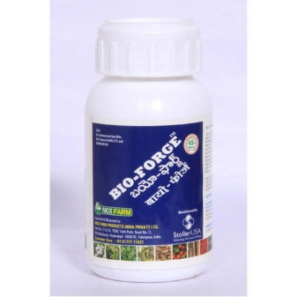

### Product Specification

|  |  |
| --- | --- |
| Packaging Size | 1 liter |
| Pack Type | Bottle |
| Form | Liquid |
| Brand | Nex farm |
| Pack Size | 1 litre |
| Minimum Order Quantity | 100 Bottle |

### Product Description

**Bio Forge Liquid Fertilizer**-develops stress resistance and disease resistance in plants when used at an early stage.

* Contains Nitrogen and Potassium along with a proprietary formulation.
* Helps maintain hormone balance in a plant during stressful periods such as drought, flooding, extreme temperatures.
* Improves germination and seedling vigor. Develops stress and disease resistance when used at early stage. (i.e., seed treatment or 4-leaf stage)
* Can be used in rice, maize, cotton, chillies and all types of fruits and vegetables.

*Price mentioned applies to bulk purchase( 50 -100 litres) GST and transportation extra.  
*Available in 10L, 35L, 50L, 100L and 208L.

1. **Azotobacter Agri Life Nitrofix RZ Bio Fertlizer, Packaging Type: Packet, Packaging Size: 1 Kg**

Price:- 52.76/kg

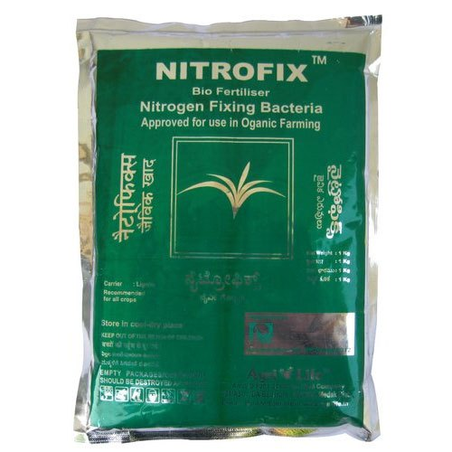

### Product Specification

|  |  |
| --- | --- |
| Usage/Application | Organic Farming |
| Brand | Agri Life |
| Types Of Biofertilizers | Azotobacter |
| Packaging Size | 1 Kg |
| Packaging Type | Packet |
| Grade Standard | Bio-Tech Grade |
| Form | Powder |
| Shelf Life | 12 Months |
| Minimum Order Quantity | 10 Kg |

### Product Description

* Agri Life NITROFIX - RZ is a biological fertilizer based on a selected strain of naturally-occurring beneficial bacteria - *Rhizobium japonicum* (NCIM 2743 ). They actively fix atmospheric nitrogen through a symbiotic relation with the leguminous plants. It is used as an effective soil application product.
* Agri Life NITROFIX - RZ contains vegetative cells of Rhizobium japonicum . It is formulated as carrier based powder with CFU count of 5 X 10 ^ 7 / g. and as 1*10^8 CFU/ml Liquid. NITROFIX TM - RZ is registered under the Fertilizer Control Order- Govt of India.
* NITROFIX - RZ is approved for use in Organic Agriculture.Target Nutrition Nitrogen supplementation for legumes.
* Crops Agri Life NITROFIX - RZ is suitable for application on leguminous crops such as Ground nut, Black gram, Green gram, Red gram, Cow pea, Bengal gram, Mustard, Soy bean, French bean, Cluster bean, Lab-Lab, Sesbania and many more of the legume species.
* Shelf Life Agri Life NITROFIX TM - RZ is stable for a period of 12 months from the date of manufacturing

1. Soil Rhizobium S Sol B - Sulphur Solubilizing Bacteria, For Seeds, Packaging Type: Packet

Price:-100/kg

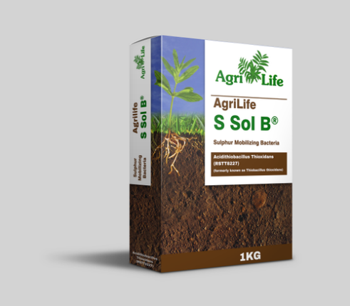

### Product Specification

|  |  |
| --- | --- |
| Packaging Type | packet |
| Color | Brown |
| Packaging Size | Bottle |
| Types Of Biofertilizers | Rhizobium |
| Product Type | soil |
| Target Crops | Vegetables |
| Usage/Application | Seeds |
| Grade Standard | Bio-Tech Grade |

### Product Description

**Introducing S Sol B®**  
  
S Sol B® is a biological fertilizer based on a selected  strain of naturally-occurring beneficial autotrophic, acidophilic bacteria Tthiobacillus thioxidans (NCIM 5069). Tthiobacillus thioxidans is a gram negative, rod shaped, non sporing bacteria. It is used as an effective soil inoculant.

1. Brown Organic Neem Manure, Packaging Type: Hdpe Bag, Pack Size: 50 Kg

Price:- 15/kg

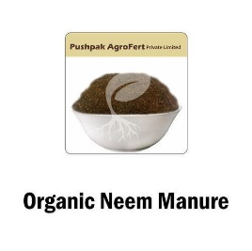

### Product Specification

|  |  |
| --- | --- |
| Usage/Application | Agriculture |
| Brand | Pushpak Agro Fert |
| Pack Size | 50 kg |
| Form | Powder |
| Packaging Type | HDPE Bag |
| Color | Brown |
| Material | Neem |
| Product Type | Organic |
| Minimum Order Quantity | 5000 Kg |

### Product Description

This **Organic Neem Manure** is used to protect the roots of plants from nematodes, soil grubs, white ants, etc.

1. **Nitro Plus 9 Liquid Fertilizer, For Used For Crops And Plant, Pack Size: 1 Liter**

Price:-516/bottle

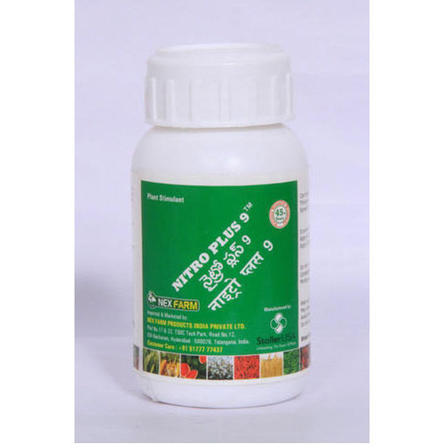

### Product Specification

|  |  |
| --- | --- |
| Packaging Size | 1 litre |
| Usage/Application | Use during vegetative/ flowering stage.Mix 5 ml with 1 litre of water and apply on plants/trees |
| Pack Type | Bottle |
| Usage | Used For Crops And Plant |
| Form | Liquid |
| Target Crops | All crops and plants |
| State | Liquid |
| Weight | 1 liter |
| Quantity Per Pack | 1 |
| Is It Organic | In Organic |
| Brand | Nex Farm |
| Pack Size | 1 liter |
| Minimum Order Quantity | 500 Bottle |

### Product Description

**Nitro Plus 9 Liquid Fertilizer**-promotes even crop development  
-Ensures higher yield.

* Calcium and other growth supporting co factors enhance plant growth and yield
* makes roots more vigorous
* Increased resistance to disease
* Improved storage life
* Promotes even crop development and higher yield

*Price mentioned applies to bulk purchase  (50 - 100 litres) GST and Transportation extra  
*Available in 10L, 35L,50L,100L and 208L.

1. Bio-Tech Grade Packaging Size: 40kg Dharani Organic Fertilizer, For Agriculture

Price:-1500/bag

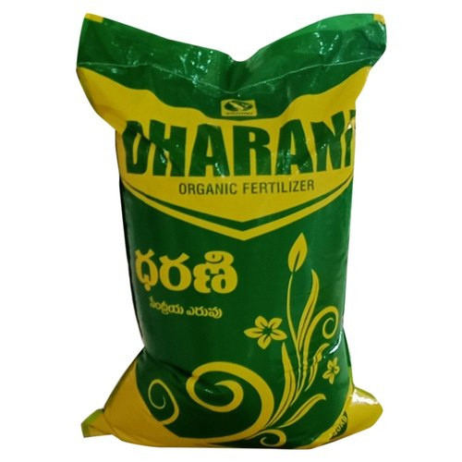0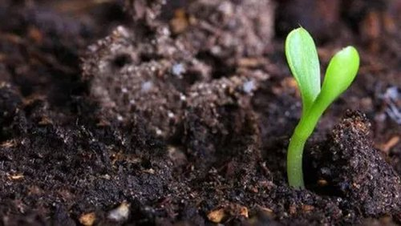

### Product Specification

|  |  |
| --- | --- |
| Usage/Application | Agriculture |
| Packaging Size | 40kg |
| Grade Standard | Bio-Tech Grade |
| Shelf Life | 1 Year |
| Packaging Type | Bag |
| Minimum Order Quantity | 100 Bag |

1. **Bio-Tech Grade Cyston Granules (Emamectin) Biopesticides, For Agriculture, Target Crops: Vegetables**

Price:-160/bottle

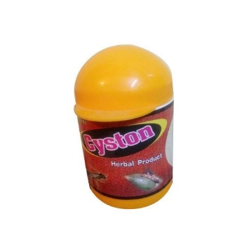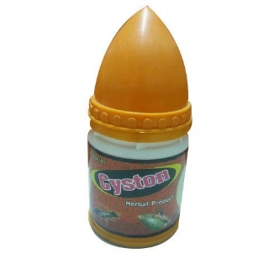

### Product Specification

|  |  |
| --- | --- |
| Form | Granules |
| Packaging Size | 100gm/acre&250gm |
| Usage/Application | Agriculture |
| Target Crops | Vegetables |
| Grade Standard | Bio-Tech Grade |
| Brand | Cryston Granules |
| Pack Size | 100 gms |
| Dosage | 100 gms per acre |
| Packaging Type | Bottle |
| Minimum Order Quantity | 20 Bottle |

### Product Description

Our company has earned accolades in offering Cyston Granules Fertilizer.  
Cyston granules are Insecticidal&Larvicidal which can be recommended for heliothris,bollworm,caterpillars  in all crops especially in pulses,,vegetables.  
100gms granules/acre

1. Agricultural Grade 50 Litres Drum Humic Liquid Fertilizer

Price:-100/liter

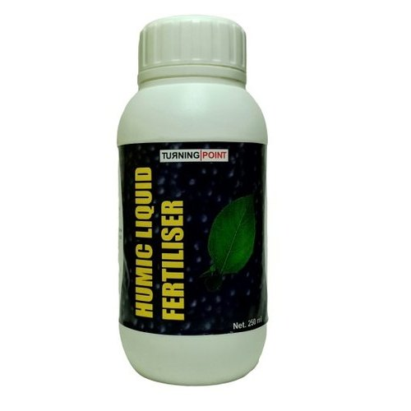

### Product Specification

|  |  |
| --- | --- |
| Purity | 99 % |
| Packaging | 50 Litres Drum |
| Grade | Agricultural Grade |
| Usage/Application | Fertilizer |
| Packaging Size | 250ml |
| Form | Liquid |
| Brand | Chipku |
| Pack Type | Barrel |

### Product Description

**Available in Packing Size: -**

* 100 ml
* 250 ml
* 500 ml
* 1 Ltr.
* 5 Ltr.

**Dosage Application: -**

For Spray & Drenching Mix 1 – 2 ml **Humic Liquid Fertiliser** with 1 Ltr Water

**Humic Fertiliser Description: -**

Humic acid is a group of molecules that bind to, and help plant roots receive, water and nutrients. High humic acid levels can dramatically increase yields. Humic acid deficiency can prevent farmers and gardeners from growing crops with optimum nutrition. Conventional wisdom today ignores humic acids, though, holding that it is impossible to grow and maintain an urban landscape such as a park, golf course, or lawn without high-analysis NPK fertilizers.

**Feature & Benefits: -**

* Humic Acid- Super pottatium humate water soluble
* Organic fertiliser for plant/water soluble/useful for spray & drenching or soil application
* Good source of Organic Humus recommended in organic farming
* Enhance root development /Increase stem thickness /increase nutrient uptake / Increase crop yield
* Improve soil fertlity & soil structure/increase water retension/Improve microbial growth
* Result oriented product

1. Controlled Potassium Humate

Price:-150/kg

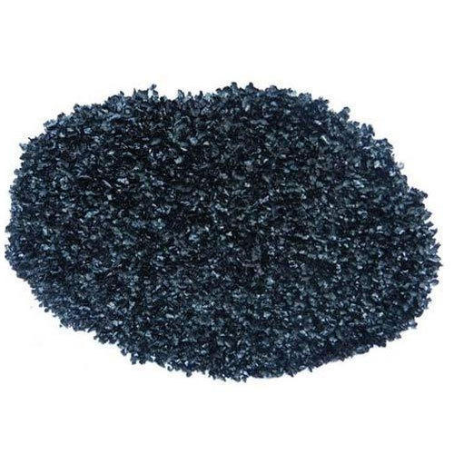

### Product Specification

|  |  |
| --- | --- |
| Release Type | Controlled |
| Usage/Application | Agriculture |
| Packaging Size | 1 Kg |
| Packaging Type | Packet |
| Color | Black |
| Pack Type | Packet |
| Pack Size | 1 kg |
| State | Powder |
| Humic Acid | 40 to 60 % |
| Is It Organic | Organic |
| Cleaning Agent | No |

### Product Description

We are the most trusted name amongst the topmost companies in this business, instrumental in offering a high-quality array of Potassium Humate Fertilizer.

1. EM Solution, For Agriculture, Target Crops: Vegetables

Price:- 300/liter

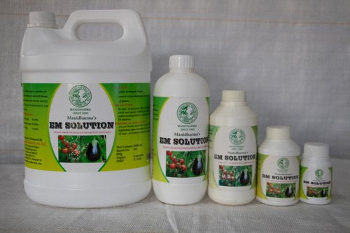 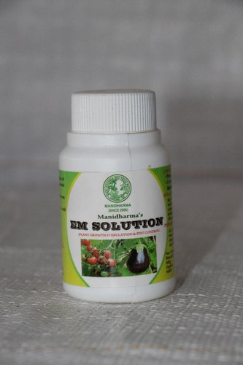 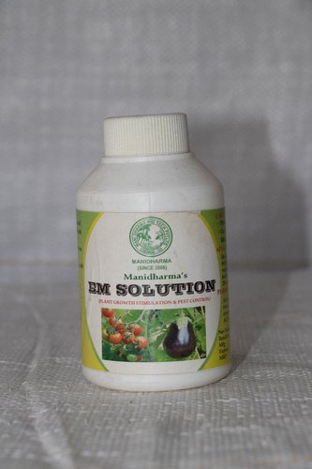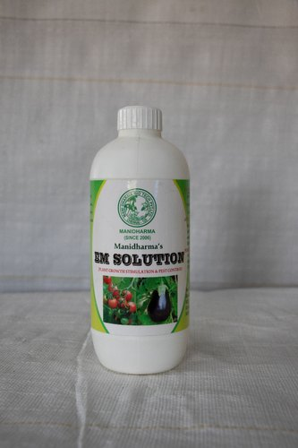 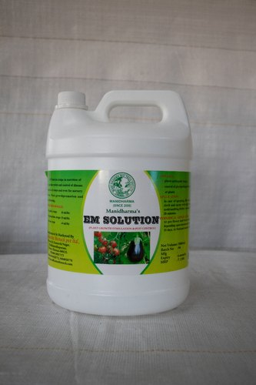

### Product Specification

|  |  |
| --- | --- |
| Usage/Application | Agriculture |
| Packaging Size | 100ml,250ml,500ml,1ltr,5ltr |
| Target Crops | Vegetables |
| Product Type | Organic |
| Grade | Bio- Tech |
| Packaging Type | Plastic Container |
| State | Liquid |
| Brand | Manidharma |

### Product Description

Effective Microorganisms (**EM**) If I had to choose one product as being the most important for the garden, effective microorganisms would be it.  
  
 **EM** is a liquid  mixture of important probiotic, beneficial microorganisms that are known to work cooperatively to provide tremendous benefits for soil and plants.

SEEDS

1. Natural Spiny Gourd Seeds, Packaging Type: Courier Package

Price:- 5000/kg

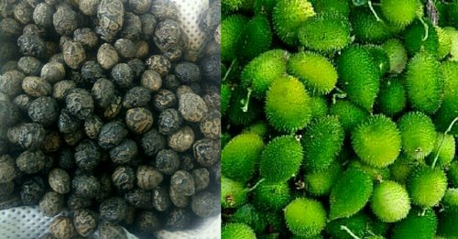 

### Product Specification

|  |  |
| --- | --- |
| Type | Natural |
| Packaging Size | 50 gms, 100 gms, 250 gms, 500 gms, 1 kg , 2kg, 3 kg, 5 kg, 10 kg |
| Color | Natural |
| Packaging Type | Courier Package |
| Germination Rate | 80 |
| Is It Organic | Organic |
| Shelf Life | 2 years |
| Brand | Farm Fresh - Graded |
| Minimum Order Quantity | 1 Kg |

### Product Description

Pure Desi Graded Spiny Gourd/Kantola Seeds

1. Manidharma Traditional Vegetable Seeds

Price:-10/packet

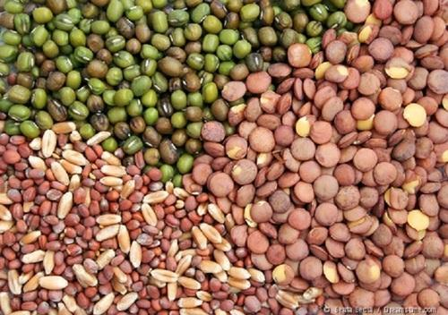

### Product Specification

|  |  |
| --- | --- |
| Brand | Manidharma |
| Type | Natural, Hulled |
| Usage/Application | Agriculture |
| Packaging Type | Polythene Cover |
| Is It Organic | Organic |
| Shelf Life | Three months |

### Product Description

We provide**Vegetable Seeds** owing the hybrid varieties of vegetables.

Know why to support Know why to support because traditional vegetable are

* Good to grow
* Taste and healthy
* Not modified genetically
* Retains the natures nourishment

1. Natural Kitchen Garden Vegetable Seeds

Price:-35/kg

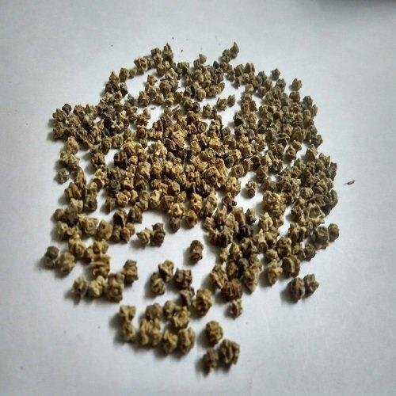 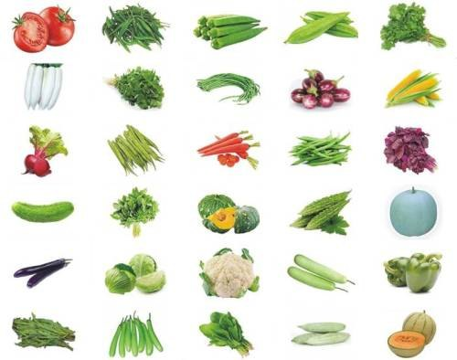

### Product Specification

|  |  |
| --- | --- |
| Brand | The Garden Kart |
| Type | Natural |
| Packaging Type | Packet |
| Is It Organic | Organic |
| Country of Origin | Made in India |

### Product Description

We are offering a wide range of **Vegetable Seeds** like Tomato, Brinjal, Ladies Finger, Chilly & Onion, Drum stick, Bottle Gourd, Bitter Gourd, Carrot, Ridge Gourd, Sweet Corn, Radish, Beetroot, Arai Keerai, Pumpkin, Avarai, Thandu Keerai, Red Thandu keerai, Paruppu Keerai, Cluster Beans, sirukeerai, Agathi keerai, cucumber, cauliflower, watermelon, cabbage, Roselle, Palak keerai, Climbing Beans, Papaya, Methi Keerai, kashni keerai, long Beans, French Beans.

1. Okra Kalyan Seed

Price:-4000/kg

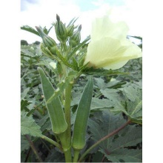

### Product Specification

|  |  |
| --- | --- |
| Pack Type | (100,500,1000) Gm |
| Fruit Length | Medium Short |
| Pack Size | (100,500,1000) Gm |
| Fruit Color | Dark green |
| Fruit Base | Green |
| Internode | Medium Internode |
| YVMV | Resistant |
| ELCV | Tolerant |
| Yield | Good |

### Product Description

Being a well-distinguished company in the market, we are into offering **Okra Kalyan Seed.**

1. **Dolichos Seeds, For Sowing Seed**

Price:- 150\packet

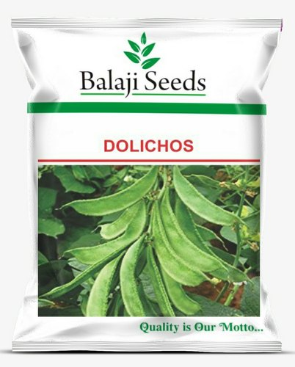

### Product Specification

|  |  |
| --- | --- |
| Usage/Application | Sowing Seed |
| Type | Natural |
| Packaging Type | Plastic Bag |
| Usage | Sowing Seed |
| Brand | Balaji Seeds |
| Minimum Order Quantity | 5 Packet |

1. **Red Chilli Seeds**

Price:- 480/ pack

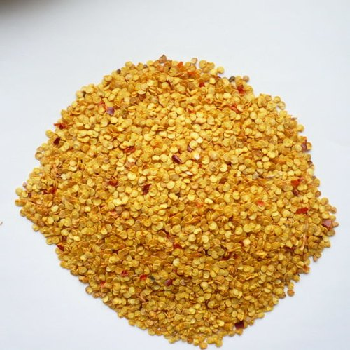

### Product Specification

|  |  |
| --- | --- |
| Usage/Application | Agriculture |
| Packaging Size | 10 Gram |
| Packaging Type | Packet |
| Country of Origin | Made in India |
| Shelf Life | 6 to 12 Months |
| Seeds Type | Hybrid |

1. **Dried Green Pumpkin Seeds**

Price:-351/kg

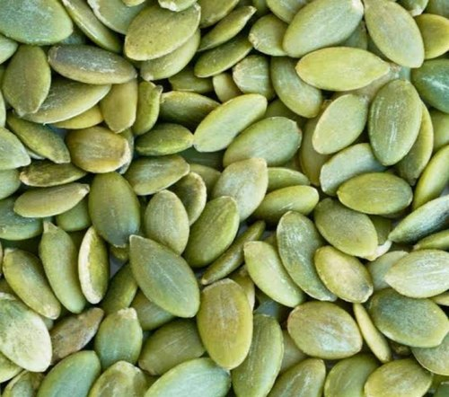

### Product Specification

|  |  |
| --- | --- |
| Brand | NO BRAND |
| Type | Dried |
| Packaging Size | 1KG,5 KG,25KG |
| Color | Green |
| Packaging Type | custom |
| Is It Organic | Organic |
| Country of Origin | Made in India |

### Product Description

IMMUNE SYSTEM: Pumpkin Seeds are a rich source of zinc and antioxidants which can help strengthen the immune system.

ZERO CHOLESTEROL: They consists of Zero cholesterol & trans fat, hence can be helpful for heart health.

FIBRE FILLED SEEDS: They are a rich source of healthy fats & packed with dietary fibre, keeping you full for longer duration & can help in weight loss.

100% NATURAL: These AAA graded premium quality pumpkin seeds are 100% natural, free from any chemicals or preservatives.

TRYPTOPHAN RICH: They are also rich in tryptophan which can help in destressing and can also help in relieving the symptoms of insomnia.

1. **Safflower Seeds/ Kusum Beej Seeds/ Kardi Seeds f (NATURAL NUTS) HAPPY FOODS**

Price:- 65/kg

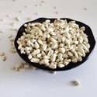 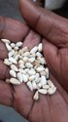 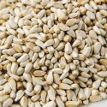

### Product Specification

|  |  |
| --- | --- |
| Type | Natural |
| Brand | NATURALNUTS (HAPPY FOODS |
| Packaging Size | 50 KG |
| Color | White |
| Is It Organic | Organic |
| Country of Origin | Made in India |

### Product Description

Safflower, Carthamus tinctorius, is a highly branched, herbaceous, thistle-like annual plant. It is commercially cultivated for vegetable oil extracted from the seeds and was used by the early Spanish colonies along the Rio Grande as a substitute for saffron.Safflower oil is a rich source of unsaturated fatty acids, which are often called "good fats." It's every bit as healthy as olive oil and canola oil. But it has less flavor than those alternatives and is often less expensive.

1. **Natural Multicolor Vegetables Seeds**

Price:-195/pack

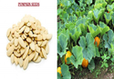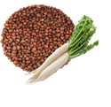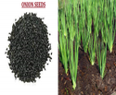

### Product Specification

|  |  |
| --- | --- |
| Brand | MGBN |
| Type | Natural |
| Color | Multicolor |
| Packaging Type | SACHET |
| Usage/Application | seeds |
| Country of Origin | Made in India |

### Product Description

VEGETABLES SEEDS  
  
1.ONION-PYAZ (LARGE) SEED (DESI)  
2.PUMPKIN SEEDS  
3.RADDHISH SEED (DESI)

1. **Natural Organic Spinach Seed**

Price:-20/pack

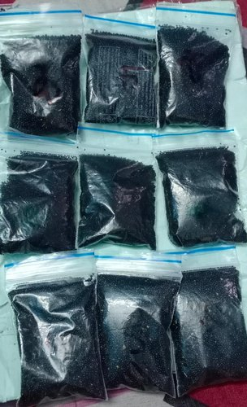

### Product Specification

|  |  |
| --- | --- |
| Type | Natural |
| Packaging Size | 50 Gram |
| Packaging Type | Packet |
| Is It Organic | Organic |
| Country of Origin | Made in India |

1. Hybrid Vegetable Seeds

Price:-90/one piece

### Hybrid Vegetable Seeds, Packaging Type: Stand Up Pouch Packing, Packaging Size: 50gms,100gmsHybrid Vegetable Seeds, Packaging Type: Stand Up Pouch Packing, Packaging Size: 50gms,100gmsHybrid Vegetable Seeds, Packaging Type: Stand Up Pouch Packing, Packaging Size: 50gms,100gmsHybrid Vegetable Seeds, Packaging Type: Stand Up Pouch Packing, Packaging Size: 50gms,100gmsHybrid Vegetable Seeds, Packaging Type: Stand Up Pouch Packing, Packaging Size: 50gms,100gmsHybrid Vegetable Seeds, Packaging Type: Stand Up Pouch Packing, Packaging Size: 50gms,100gmsProduct Specification

|  |  |
| --- | --- |
| Brand | Sattur |
| Type | Hybrid |
| Packaging Size | 50gms, 100gms |
| Color | natural color of seeds |
| Packaging Type | Stand Up Pouch packing |
| Harvesting Days | 70-90 |
| Is It Organic | In Organic |
| Shelf Life | 1 year |
| Minimum Order Quantity | 100 one piece |

### Product Description

Tomato seeds, okra, Gourds, Chilly, Pumpkin, Brinjal, Maize, watermelon. musk melon

1. Moringa Seeds

Price:- 560/kg

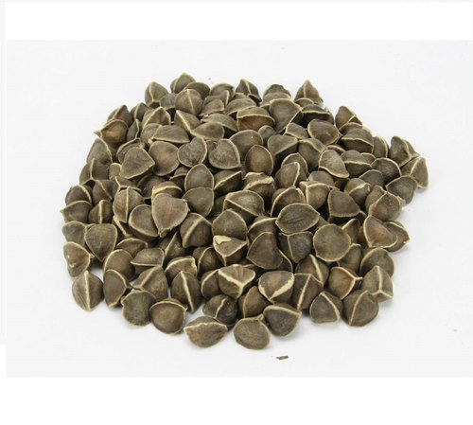

### Product Specification

|  |  |
| --- | --- |
| Type | Natural |
| Dried | Yes |
| Cultivation Type | Organic |
| Country of Origin | INDIA |
| Organic | Yes |
| Minimum Order Quantity | 20 Kilogram |

### Product Description

We are the leading exporter and supplier of **Moringa Seeds**.

1. Hybrid Green Ekdal Sada Danta Vegetable Seed

Price:-90/pack

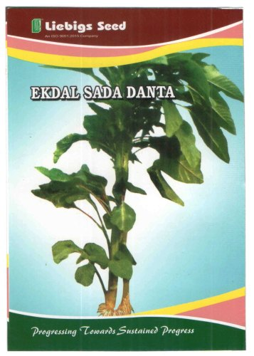

### Product Specification

|  |  |
| --- | --- |
| Brand | Liebigs |
| Type | Hybrid |
| Packaging Size | 100g |
| Color | Green |
| Packaging Type | Paper Box |
| Usage/Application | Agricultural Use |
| Shelf Life | 9 Months From Manufacturing Date |
| Moisture | 70 % |
| Country of Origin | Made in India |
| Seed Variety | Ekdal Sada |

1. Natural Vegetable Seeds

Price: :- 50/kg

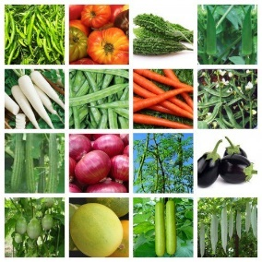

### Product Specification

|  |  |
| --- | --- |
| Type | Natural |
| Packaging Size | 50g & 100g |
| Packaging Type | 5o g |
| Usage/Application | Agriculture |
| Is It Organic | Organic |

### Product Description

The quality and healthy seed and plants or planting materials holds the key in success of crop production and also yield levels. It is understood that quality seeds alone is known to account for at least 10-15% increase in the productivity. Seeds and plants suitable for terrace gardening and home consumption to be provided to promote urban agri concepts. Making seeds and plants available in smaller quantity is also a challenge. Keeping this in view, Way2Agritech offers quality and tested seeds & plants in the size or number required by its customers.